Changes to MHV for October 2017

# Case I. Not Logged-In User

### 1. MHV Home Page

### 2. Keeping Up With All Your VA Appointments

**MARVEL FLOW:** <https://marvelapp.com/25da441>

## Case II. Logged-In User, VAR Ineligible, Basic or Advanced (User has basic OR advanced account)

### MHV Home Page

### Error Page

## MARVEL Flow: <https://marvelapp.com/2iea500>

# Case III. Logged-In Premium User, VAR Ineligible, Not in Field Test Group

**(User not in field test group: e.g. user doesn’t go to a VAR-participating facility; user has not had an appointment in 2 years; user is at throttled facility)**

### 1. MHV Home Page

### 2. MHV Appointments Page

### 3. Scheduling Transition

**MARVEL Flow:** [**https://marvelapp.com/6h0ad1b**](https://marvelapp.com/6h0ad1b)

# Case IV. Logged-In User, VAR Eligible

### 1. MHV Home Page

### 2. View My VA Appointments Page

**3. Transition Page**

**MARVEL Flow:** [**https://marvelapp.com/a5ag109**](https://marvelapp.com/a5ag109)

# Case 1. Not Logged-In User

## Case 1 – Not Logged-In User Home Page (<https://www.myhealth.va.gov>)

## 

1. Change VAR grey button design text to say **“Schedule a VA Appointment”**
2. Change button link for a **not logged in user** to redirect to: <https://www.myhealth.va.gov/mhv-portal-web/web/myhealthevet/keeping-up-with-all-your-va-appointments>

## Case 1. Keeping Up with All Your VA Appointments (<https://www.myhealth.va.gov/mhv-portal-web/web/myhealthevet/keeping-up-with-all-your-va-appointments>)

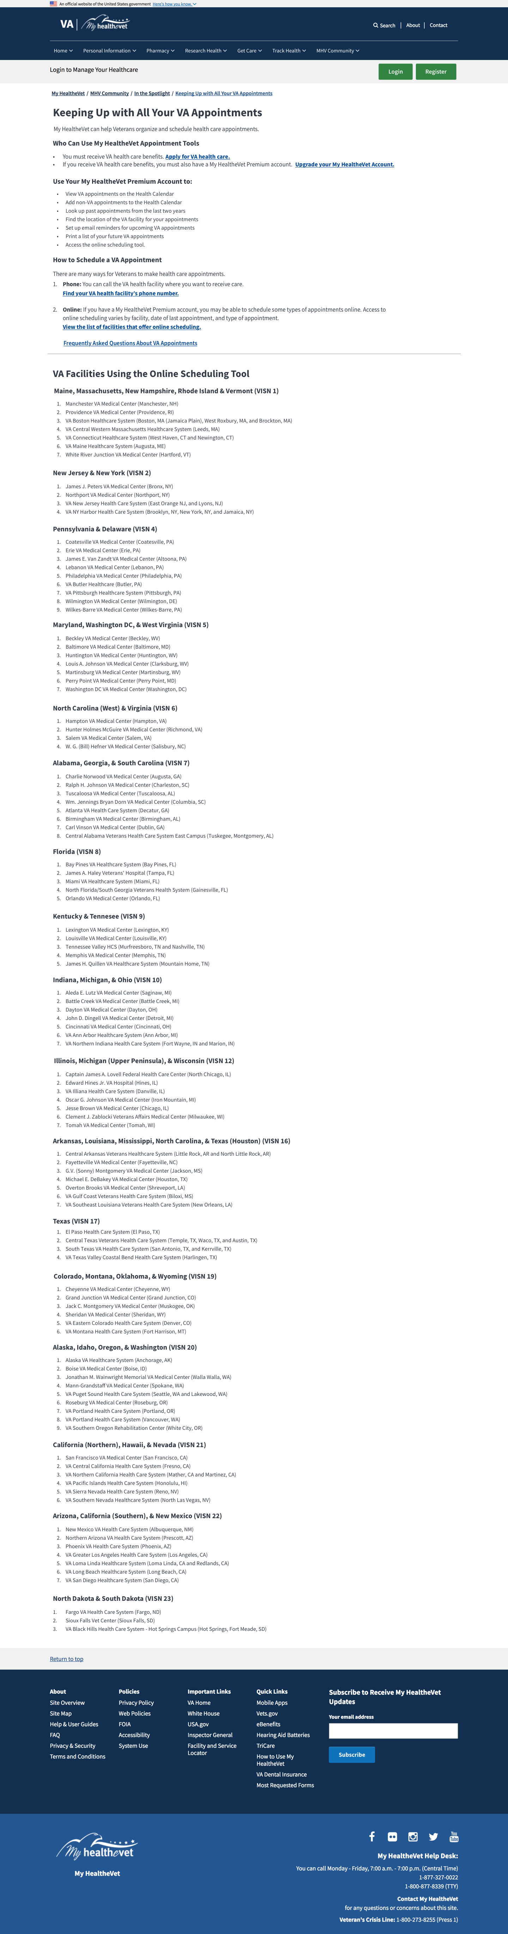

1. UPDATE: Change content on this page. (New Content, with links & header levels below)
2. Added an anchor link with the list of facilities that participate in VAR. The list of facilities will be dynamic web content that can be added to this page, and to the Scheduling Transition page, case 4.

# Content for new Keeping Up page:

# Keeping Up with All Your VA Appointments

My HealtheVet can help Veterans organize and schedule health care appointments.

## Who Can Use My HealtheVet Appointment Tools

• You must receive VA health care benefits. [Apply for VA health benefits.](https://www.vets.gov/health-care/apply/)

• If you receive VA health care benefits, you must also have a My HealtheVet Premium account. [Upgrade my account to Premium](https://www.myhealth.va.gov/mhv-portal-web/web/myhealthevet/upgrading-your-my-healthevet-account-through-in-person-or-online-authentication).

## Use Your My HealtheVet Premium Account to:

* View VA appointments on the Health Calendar
* Add non-VA appointments to the Health Calendar
* Look up past appointments from the last two years
* Find the location of the VA facility for your appointments
* Set up email reminders for upcoming VA appointments
* Print a list of your future VA appointments
* Access the online scheduling tool.

## How to Schedule an Appointment

There are a few ways for Veterans to make a health care appointment.

1. **Phone:** You can call the VA health facility where you want to receive care to make an appointment. [Find your VA health facility’s phone number.](https://www.vets.gov/facilities/)
2. **Online:** If you have a My HealtheVet Premium account, you may be able to schedule some types of appointments online. Access to line scheduling varies by facility, date of last appointment, and type of appointment. View the list of facilities that offer online scheduling.

## [Frequently Asked Questions about VA Appointments](https://www.myhealth.va.gov/mhv-portal-web/web/myhealthevet/va-appointments-faqs)

# VA Facilities Using the Online Scheduling Tool

**Maine, Massachusetts, New Hampshire, Rhode Island & Vermont (VISN 1)**

1. Manchester VA Medical Center (Manchester, NH)
2. Providence VA Medical Center (Providence, RI)
3. VA Boston Healthcare System (Boston, MA (Jamaica Plain), West Roxbury, MA, and Brockton, MA)
4. VA Central Western Massachusetts Healthcare System (Leeds, MA)
5. VA Connecticut Healthcare System (West Haven, CT and Newington, CT)
6. VA Maine Healthcare System (Augusta, ME)
7. White River Junction VA Medical Center (Hartford, VT)

**New Jersey & New York (VISN 2)**

1. James J. Peters VA Medical Center (Bronx, NY)
2. Northport VA Medical Center (Northport, NY)
3. VA New Jersey Health Care System (East Orange NJ, and Lyons, NJ)
4. VA NY Harbor Health Care System (Brooklyn, NY, New York, NY, and Jamaica, NY)

**Pennsylvania & Delaware (VISN 4)**

1. Coatesville VA Medical Center (Coatesville, PA)
2. Erie VA Medical Center (Erie, PA)
3. James E. Van Zandt VA Medical Center (Altoona, PA)
4. Lebanon VA Medical Center (Lebanon, PA)
5. Philadelphia VA Medical Center (Philadelphia, PA)
6. VA Butler Healthcare (Butler, PA)
7. VA Pittsburgh Healthcare System (Pittsburgh, PA)
8. Wilmington VA Medical Center (Wilmington, DE)
9. Wilkes-Barre VA Medical Center (Wilkes-Barre, PA)

**Maryland, Washington DC, & West Virginia (VISN 5)**

1. Beckley VA Medical Center (Beckley, WV)
2. Baltimore VA Medical Center (Baltimore, MD)
3. Huntington VA Medical Center (Huntington, WV)
4. Louis A. Johnson VA Medical Center (Clarksburg, WV)
5. Martinsburg VA Medical Center (Martinsburg, WV)
6. Perry Point VA Medical Center (Perry Point, MD)
7. Washington DC VA Medical Center (Washington, DC)

**North Carolina (West) & Virginia (VISN 6)**

1. Hampton VA Medical Center (Hampton, VA)
2. Hunter Holmes McGuire VA Medical Center (Richmond, VA)
3. Salem VA Medical Center (Salem, VA)
4. W. G. (Bill) Hefner VA Medical Center (Salisbury, NC)

**Alabama, Georgia, & South Carolina (VISN 7)**

1. Charlie Norwood VA Medical Center (Augusta, GA)
2. Ralph H. Johnson VA Medical Center (Charleston, SC)
3. Tuscaloosa VA Medical Center (Tuscaloosa, AL)
4. Wm. Jennings Bryan Dorn VA Medical Center (Columbia, SC)
5. Atlanta VA Health Care System (Decatur, GA)
6. Birmingham VA Medical Center (Birmingham, AL)
7. Carl Vinson VA Medical Center (Dublin, GA)
8. Central Alabama Veterans Health Care System East Campus (Tuskegee, Montgomery, AL)

**Florida (VISN 8)**

1. Bay Pines VA Healthcare System (Bay Pines, FL)
2. James A. Haley Veterans' Hospital (Tampa, FL)
3. Miami VA Healthcare System (Miami, FL)
4. North Florida/South Georgia Veterans Health System (Gainesville, FL)
5. Orlando VA Medical Center (Orlando, FL)

**Kentucky & Tennesee (VISN 9)**

1. Lexington VA Medical Center (Lexington, KY)
2. Louisville VA Medical Center (Louisville, KY)
3. Tennessee Valley HCS (Murfreesboro, TN and Nashville, TN)
4. Memphis VA Medical Center (Memphis, TN)
5. James H. Quillen VA Healthcare System (Mountain Home, TN)

**Indiana, Michigan, & Ohio (VISN 10)**

1. Aleda E. Lutz VA Medical Center (Saginaw, MI)
2. Battle Creek VA Medical Center (Battle Creek, MI)
3. Dayton VA Medical Center (Dayton, OH)
4. John D. Dingell VA Medical Center (Detroit, MI)
5. Cincinnati VA Medical Center (Cincinnati, OH)
6. VA Ann Arbor Healthcare System (Ann Arbor, MI)
7. VA Northern Indiana Health Care System (Fort Wayne, IN and Marion, IN)

**Illinois, Michigan (Upper Peninsula), & Wisconsin (VISN 12)**

1. Captain James A. Lovell Federal Health Care Center (North Chicago, IL)
2. Edward Hines Jr. VA Hospital (Hines, IL)
3. VA Illiana Health Care System (Danville, IL)
4. Oscar G. Johnson VA Medical Center (Iron Mountain, MI)
5. Jesse Brown VA Medical Center (Chicago, IL)
6. Clement J. Zablocki Veterans Affairs Medical Center (Milwaukee, WI)
7. Tomah VA Medical Center (Tomah, WI)

**Arkansas, Louisiana, Mississippi, North Carolina, & Texas (Houston) (VISN 16)**

1. Central Arkansas Veterans Healthcare System (Little Rock, AR and North Little Rock, AR)
2. Fayetteville VA Medical Center (Fayetteville, NC)
3. G.V. (Sonny) Montgomery VA Medical Center (Jackson, MS)
4. Michael E. DeBakey VA Medical Center (Houston, TX)
5. Overton Brooks VA Medical Center (Shreveport, LA)
6. VA Gulf Coast Veterans Health Care System (Biloxi, MS)
7. VA Southeast Louisiana Veterans Health Care System (New Orleans, LA)

**Texas (VISN 17)**

1. El Paso Health Care System (El Paso, TX)
2. Central Texas Veterans Health Care System (Temple, TX, Waco, TX, and Austin, TX)
3. South Texas VA Health Care System (San Antonio, TX, and Kerrville, TX)
4. VA Texas Valley Coastal Bend Health Care System (Harlingen, TX)

**Colorado, Montana, Oklahoma, & Wyoming (VISN 19)**

1. Cheyenne VA Medical Center (Cheyenne, WY)
2. Grand Junction VA Medical Center (Grand Junction, CO)
3. Jack C. Montgomery VA Medical Center (Muskogee, OK)
4. Sheridan VA Medical Center (Sheridan, WY)
5. VA Eastern Colorado Health Care System (Denver, CO)
6. VA Montana Health Care System (Fort Harrison, MT)

**Alaska, Idaho, Oregon, & Washington (VISN 20)**

1. Alaska VA Healthcare System (Anchorage, AK)
2. Boise VA Medical Center (Boise, ID)
3. Jonathan M. Wainwright Memorial VA Medical Center (Walla Walla, WA)
4. Mann-Grandstaff VA Medical Center (Spokane, WA)
5. VA Puget Sound Health Care System (Seattle, WA and Lakewood, WA)
6. Roseburg VA Medical Center (Roseburg, OR)
7. VA Portland Health Care System (Portland, OR)
8. VA Portland Health Care System (Vancouver, WA)
9. VA Southern Oregon Rehabilitation Center (White City, OR)

**California (Northern), Hawaii, & Nevada (VISN 21)**

1. San Francisco VA Medical Center (San Francisco, CA)
2. VA Central California Health Care System (Fresno, CA)
3. VA Northern California Health Care System (Mather, CA and Martinez, CA)
4. VA Pacific Islands Health Care System (Honolulu, HI)
5. VA Sierra Nevada Health Care System (Reno, NV)
6. VA Southern Nevada Healthcare System (North Las Vegas, NV)

**Arizona, California (Southern), & New Mexico (VISN 22)**

1. New Mexico VA Health Care System (Albuquerque, NM)
2. Northern Arizona VA Health Care System (Prescott, AZ)
3. Phoenix VA Health Care System (Phoenix, AZ)
4. VA Greater Los Angeles Health Care System (Los Angeles, CA)
5. VA Loma Linda Healthcare System (Loma Linda, CA and Redlands, CA)
6. VA Long Beach Healthcare System (Long Beach, CA)
7. VA San Diego Healthcare System (San Diego, CA)

**North Dakota & South Dakota (VISN 23)**

1. Fargo VA Health Care System (Fargo, ND)
2. Sioux Falls Vet Center (Sioux Falls, SD)
3. VA Black Hills Health Care System - Hot Springs Campus (Hot Springs, Fort Meade, SD)

# Case 2: Logged-In User, VAR Ineligible, Basic or Advanced

## Case 2 Home Page

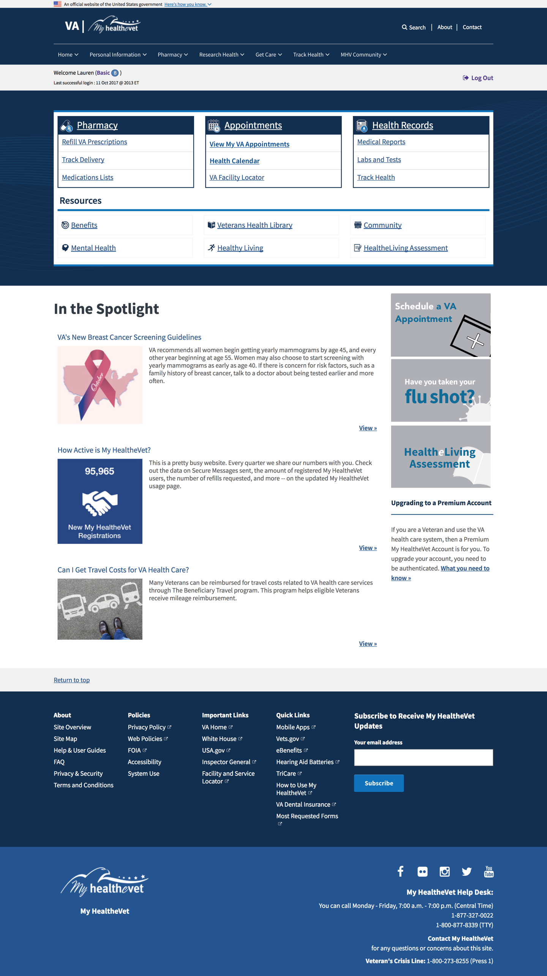

1. In the Appointments Tile: Update “VA Appointments” to “View My VA Appointments”

2b. Change grey button text to “Schedule a VA Appointment” and direct these users to the Premium error page (same thing you’d get to if you clicked “VA Appointments” as a basic or advanced user.

## Case 2 Error Page

* 1. Updated error page box content

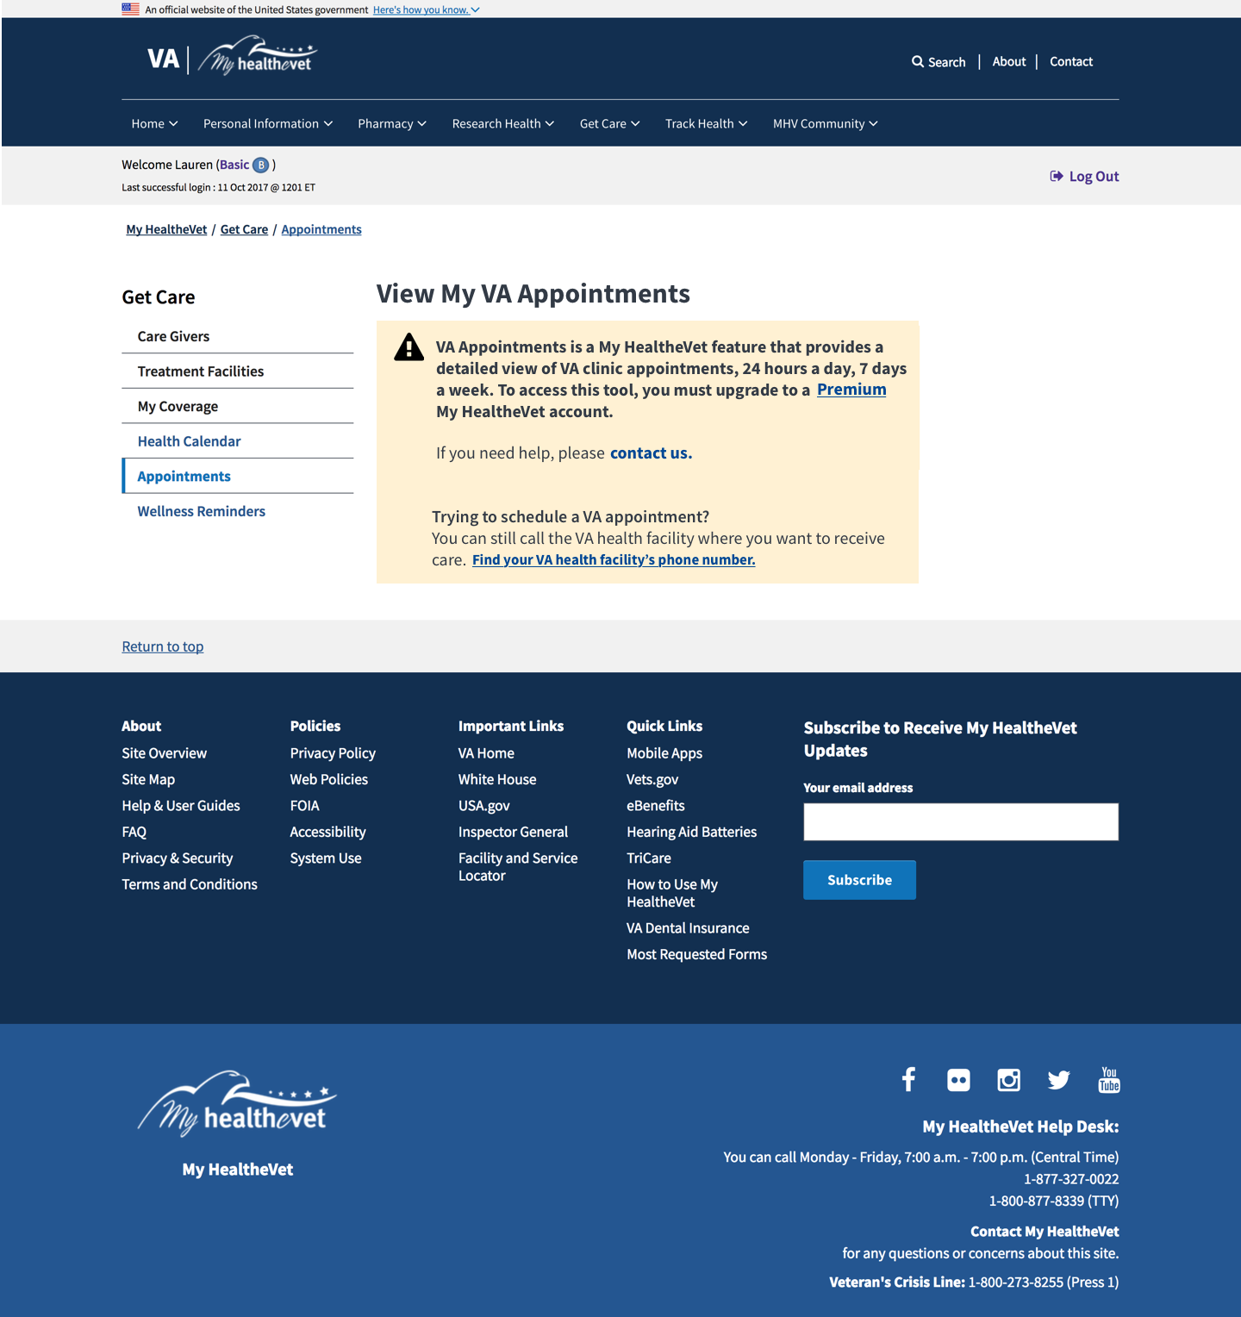

## New Content for Case 2 Error Page:

**VA Appointments is a My HealtheVet feature that provides a detailed view of VA clinic appointments, 24 hours a day, 7 days a week. To access this tool, you must upgrade to a [Premium](https://www.myhealth.va.gov/mhv-portal-web/web/myhealthevet/my-healthevet-offers-three-account-types" \l "premium) My HealtheVet account.**

If you need help, please [contact us](https://www.myhealth.va.gov/mhv-portal-web/web/myhealthevet/contact-us).

**Trying to schedule a VA appointment?**

You can still call the VA health facility where you want to receive care. [Find your VA health facility’s phone number.](https://www.vets.gov/facilities/)

# Case III. Logged-In User, VAR Ineligible B/c Not in Field Test Group

## Case III Home Page

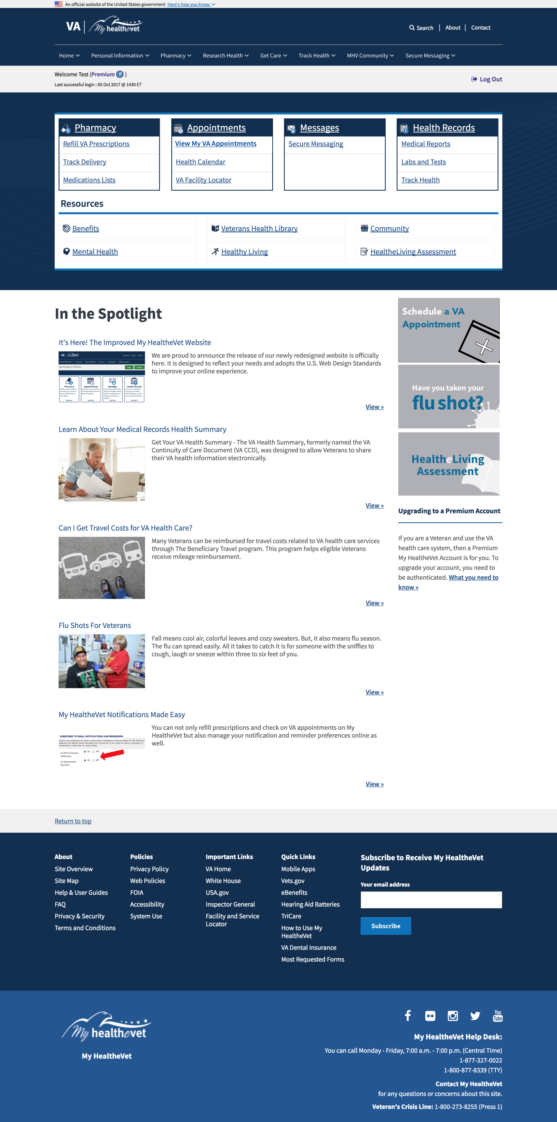

1. In Appointments Tile: Update link text to “View My VA Appointments”
2. Grey box: Schedule a VA Appointment.
3. Redirect this button to a special version of the transition page (shown on following pages).

## Case 3: View My VA Appointments Page (VAR Ineligible User, not in field test grp)

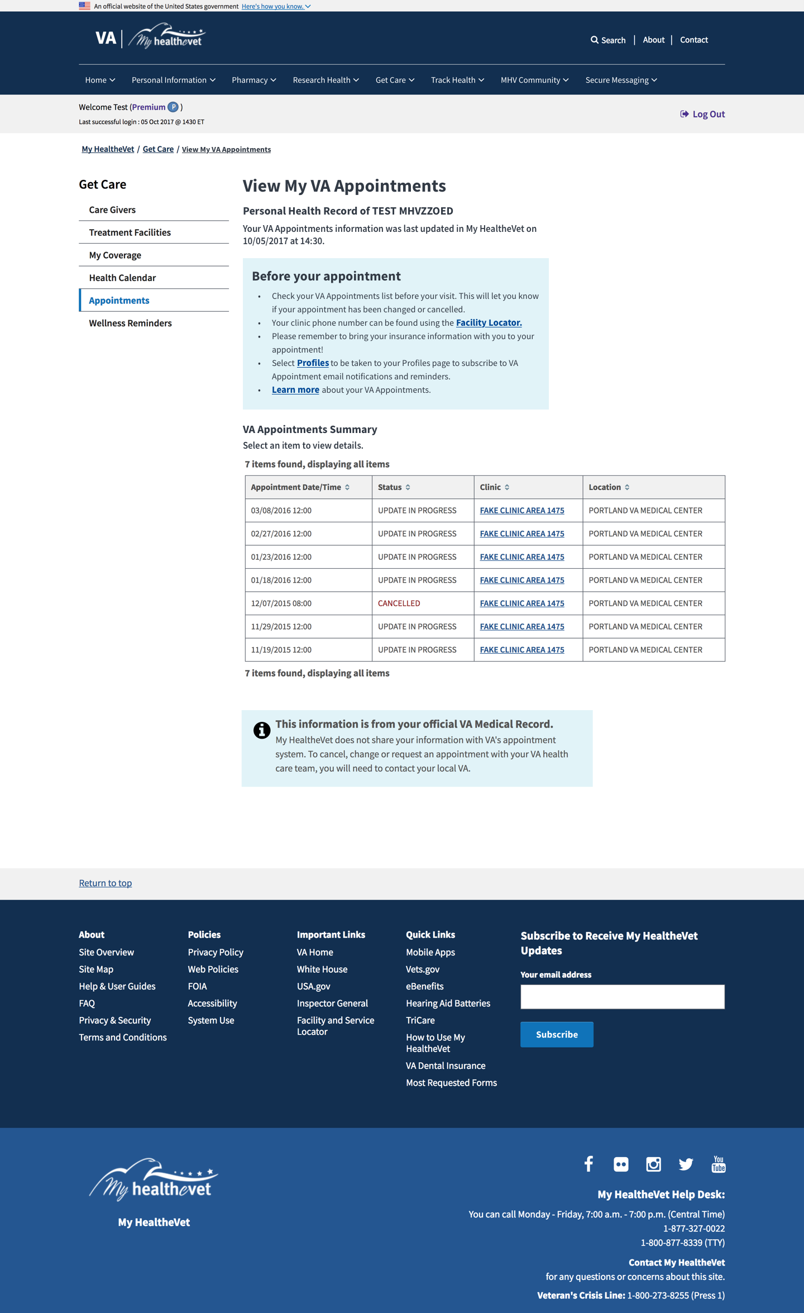

1. This page content will change. Primarily, what changes is the order that information is presented in. See next page for content order.

## Case 3: View My VA Appointments Page Content:

Update Bookmark (if possible): View My VA Appointments

# View My VA Appointments

## Personal Health Record of {Name}

Your VA Appointments information was last updated on MyHealtheVet on {date} at {time}.

## Before Your Appointment

* Check your VA Appointments list before your visit. This will let you know if your appointment has been changed or cancelled.
* Your clinic phone number can be found using the [Facility Locator.](https://www.vets.gov/facilities/)
* Please remember to bring your insurance information with you to your appointment!
* Select [Profiles](https://www.myhealth.va.gov/mhv-portal-web/web/myhealthevet/profiles) to be taken to your Profiles page to subscribe to VA Appointment email notifications and reminders.
* [Learn more](https://www.myhealth.va.gov/mhv-portal-web/web/myhealthevet/va-appointments) about your VA Appointments.

## VA Appointments Summary

Select an item to view details.

|  |  |  |  |
| --- | --- | --- | --- |
|  |  |  |  |
|  |  |  |  |
|  |  |  |  |

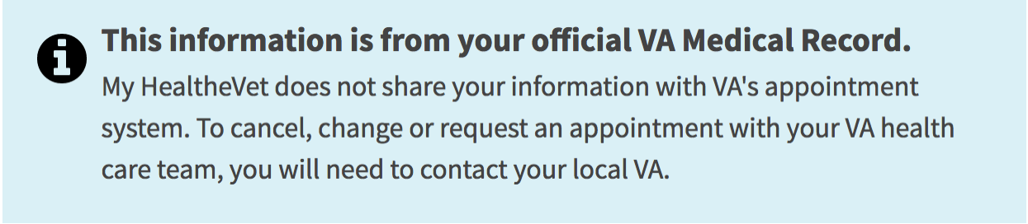

## Case 3: Scheduling Transition Page

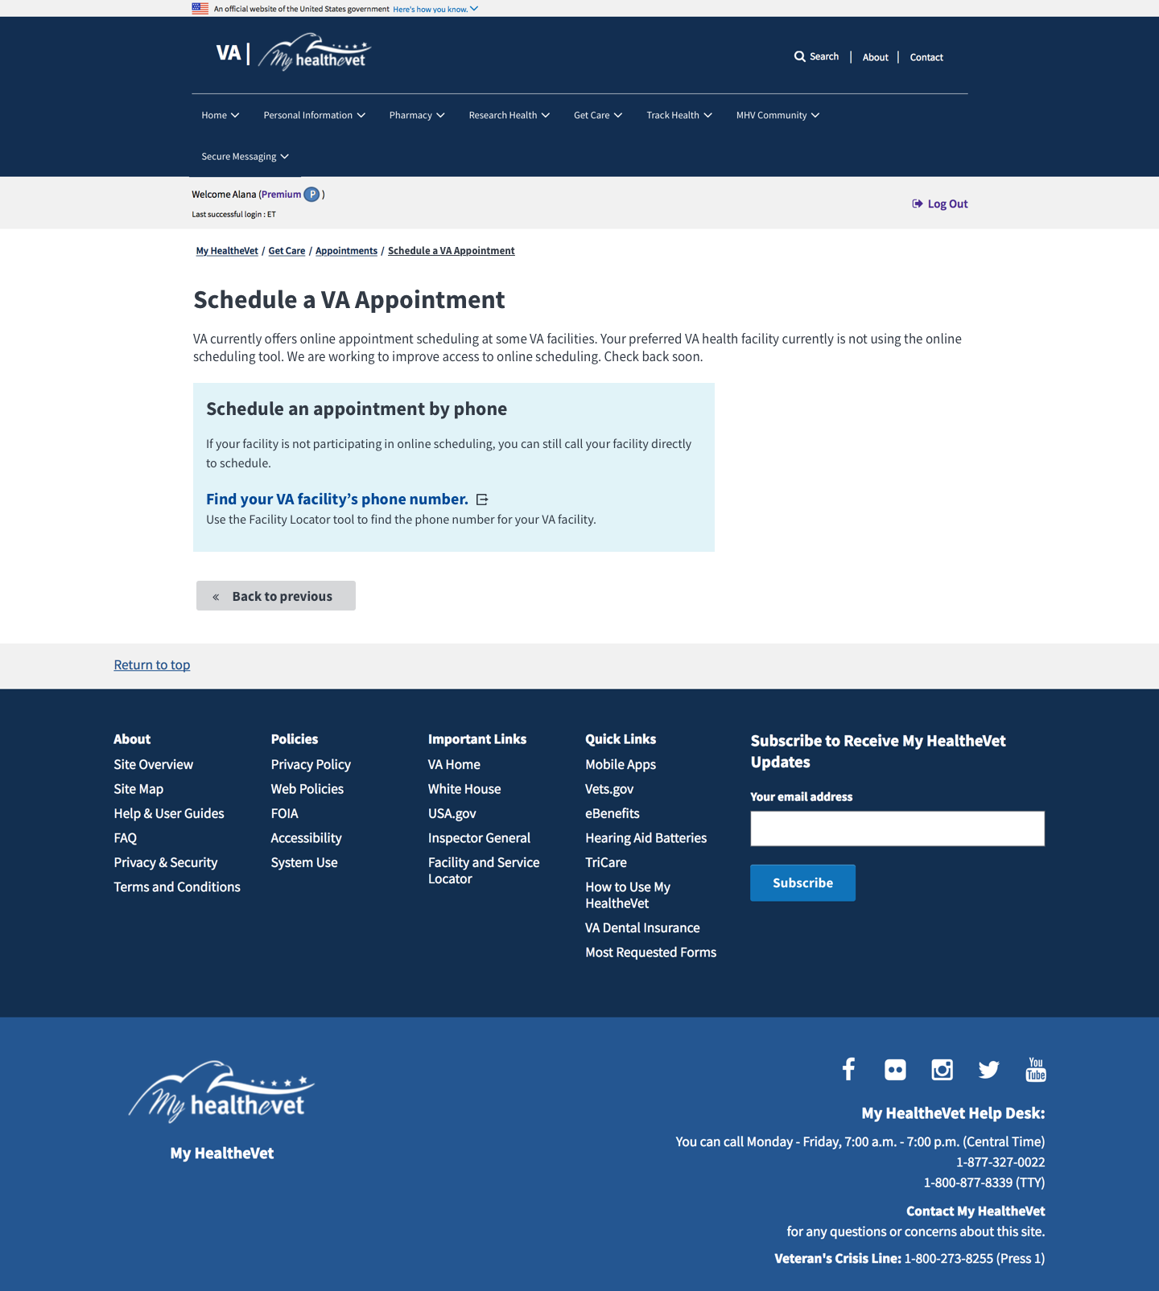

1. Users go to this transition page only if they click on “Schedule a VA Appointment” grey box from home page and are not in field test case or aren’t going to the right facility. Content on following page.
2. Update Bookmark link in nav.

# Case 3: Schedule a VA Appointment Transition Page Content

# Schedule a VA Appointment

VA currently offers online appointment scheduling at some VA facilities. Your preferred VA health facility currently is not using the online scheduling tool. We are working to improve access to online scheduling. Check back soon.

**Schedule an appointment by phone**

If your facility is not participating in online scheduling, or if you need a type of appointment that is currently not supported, you can still call your facility directly to schedule. **Find your VA facility’s phone number.**

Back to previous

# Case 4. Logged In, VAR Eligible User

## Case 4 Home Page

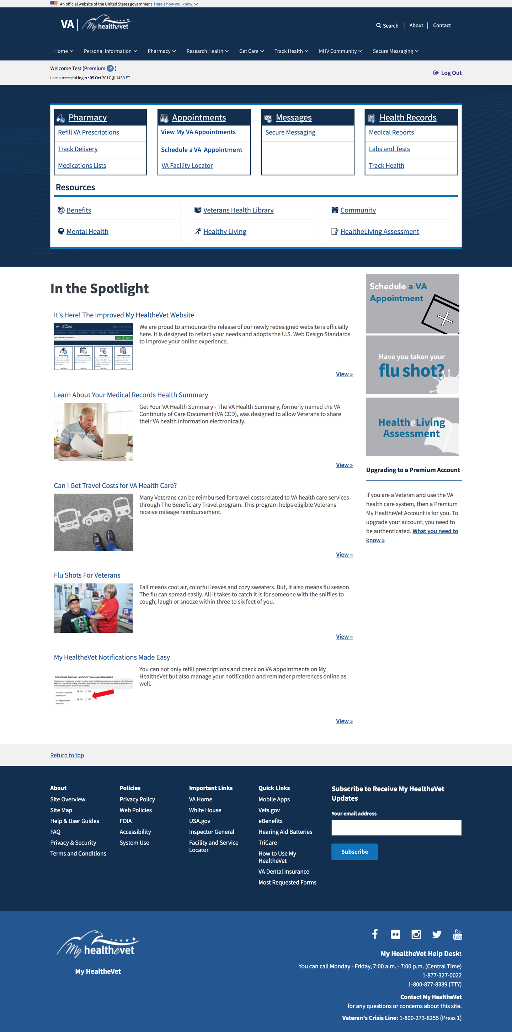

1. Update link text & link directions in Appointments Tile:
   1. View My VA Appointments
   2. Schedule a VA Appointment.
2. Update text in grey VAR box to say “Schedule a VA Appointment”

# Case 4. View My VA Appointments Page

1. Reorder page elements as shown on next page.
   1. Title: View My VA Appointments
   2. Personal Health Record of {name}
   3. Your VA Appointments was last updated on My HealtheVet on {date} at {time}
   4. New “Before Your Appointment” Blue Box
   5. VA Appointments Summary sub-head
   6. Instruction text: “Select an item to view details. “
   7. Appointments Table
   8. Schedule a VA Appointment blue button
   9. Blue box: This information is from your official VA Medical Record.
2. Update the first blue box content (same as Case 3 – View My VA Appointments)
3. Add “Schedule a VA Appointment” blue button as indicated, below the table.
4. Blue button points to Scheduling Transition page.
5. Do NOT show VAR icon in left nav.

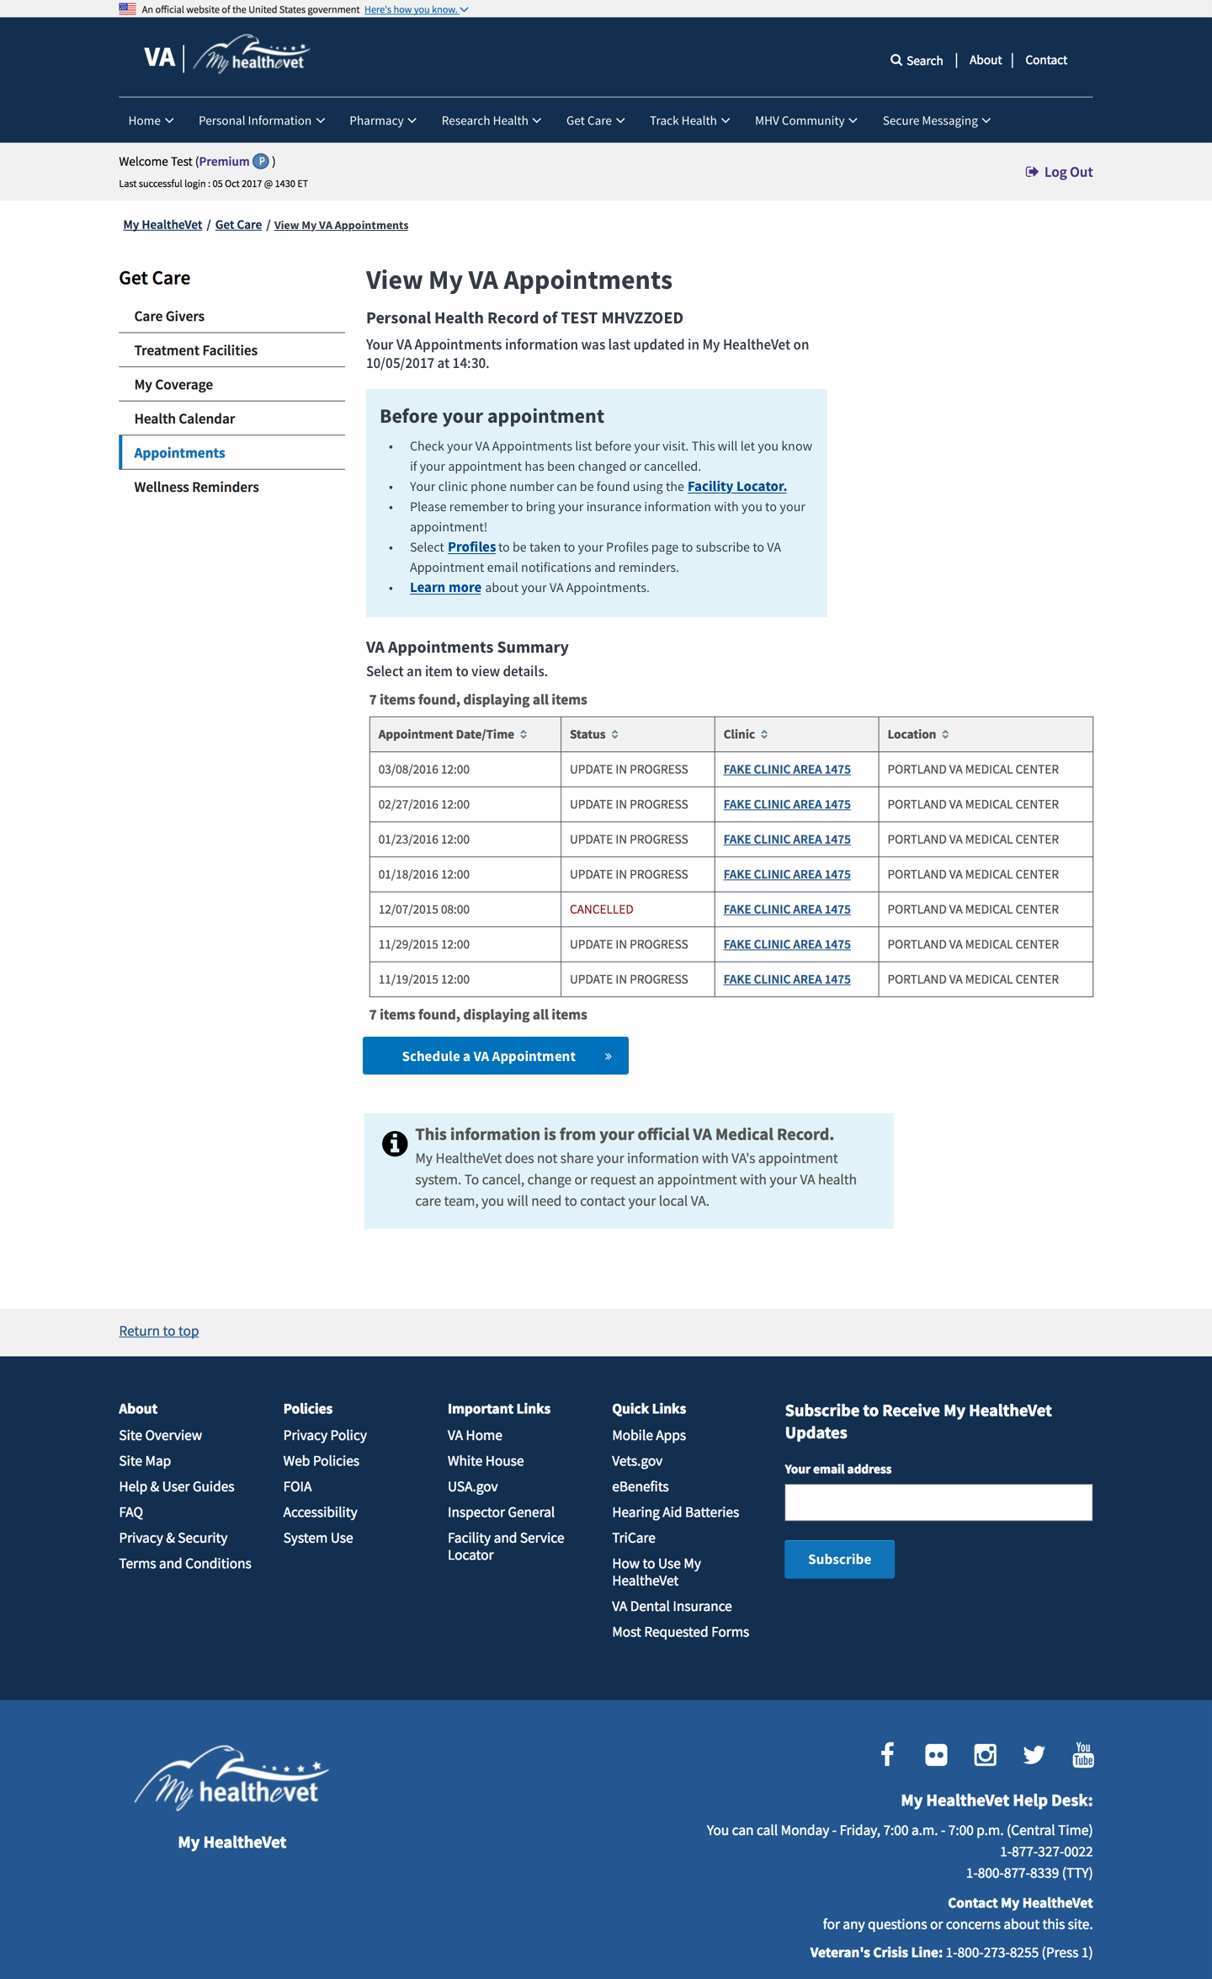

# Case 4. Scheduling Transition Page

1. Update Content as Shown. (Content on following pages – updated 10-18-17).

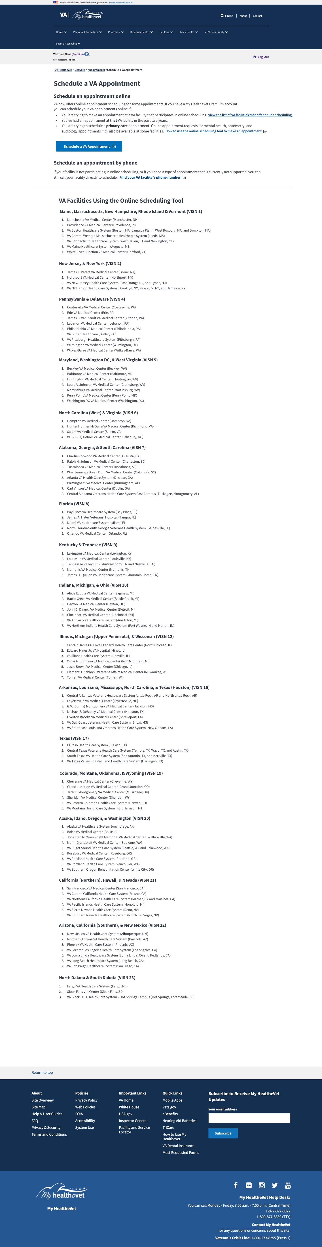

**Schedule a VA Appointment**

## Schedule an appointment online

VA now offers online appointment scheduling for some appointments. If you have a My HealtheVet Premium account, you can schedule your VA primary care and request mental health care appointments online if:

* You are requesting an appointment at a VA facility that participates in online scheduling. 
* Have had an appointment at **that** VA facility in the past two years.
* You are trying to schedule a **primary care** appointment. Online appointment requests for mental health, optometry, and audiology may also be available at some facilities. [How to use the online scheduling tool to make an appointment.](https://mobile.va.gov/sites/default/files/VAR-User-Manual-1.10.pdf)

## 

## Schedule an appointment by phone

If your facility is not participating in online scheduling, or if you need a type of appointment that is currently not supported, you can still call your facility directly to schedule. **Find your VA facility’s phone number.**

**VA Facilities Using the Online Scheduling Tool**

**Maine, Massachusetts, New Hampshire, Rhode Island & Vermont (VISN 1)**

1. Manchester VA Medical Center (Manchester, NH)
2. Providence VA Medical Center (Providence, RI)
3. VA Boston Healthcare System (Boston, MA (Jamaica Plain), West Roxbury, MA, and Brockton, MA)
4. VA Central Western Massachusetts Healthcare System (Leeds, MA)
5. VA Connecticut Healthcare System (West Haven, CT and Newington, CT)
6. VA Maine Healthcare System (Augusta, ME)
7. White River Junction VA Medical Center (Hartford, VT)

**New Jersey & New York (VISN 2)**

1. James J. Peters VA Medical Center (Bronx, NY)
2. Northport VA Medical Center (Northport, NY)
3. VA New Jersey Health Care System (East Orange NJ, and Lyons, NJ)
4. VA NY Harbor Health Care System (Brooklyn, NY, New York, NY, and Jamaica, NY)

**Pennsylvania & Delaware (VISN 4)**

1. Coatesville VA Medical Center (Coatesville, PA)
2. Erie VA Medical Center (Erie, PA)
3. James E. Van Zandt VA Medical Center (Altoona, PA)
4. Lebanon VA Medical Center (Lebanon, PA)
5. Philadelphia VA Medical Center (Philadelphia, PA)
6. VA Butler Healthcare (Butler, PA)
7. VA Pittsburgh Healthcare System (Pittsburgh, PA)
8. Wilmington VA Medical Center (Wilmington, DE)
9. Wilkes-Barre VA Medical Center (Wilkes-Barre, PA)

**Maryland, Washington DC, & West Virginia (VISN 5)**

1. Beckley VA Medical Center (Beckley, WV)
2. Baltimore VA Medical Center (Baltimore, MD)
3. Huntington VA Medical Center (Huntington, WV)
4. Louis A. Johnson VA Medical Center (Clarksburg, WV)
5. Martinsburg VA Medical Center (Martinsburg, WV)
6. Perry Point VA Medical Center (Perry Point, MD)
7. Washington DC VA Medical Center (Washington, DC)

**North Carolina (West) & Virginia (VISN 6)**

1. Hampton VA Medical Center (Hampton, VA)
2. Hunter Holmes McGuire VA Medical Center (Richmond, VA)
3. Salem VA Medical Center (Salem, VA)
4. W. G. (Bill) Hefner VA Medical Center (Salisbury, NC)

**Alabama, Georgia, & South Carolina (VISN 7)**

1. Charlie Norwood VA Medical Center (Augusta, GA)
2. Ralph H. Johnson VA Medical Center (Charleston, SC)
3. Tuscaloosa VA Medical Center (Tuscaloosa, AL)
4. Wm. Jennings Bryan Dorn VA Medical Center (Columbia, SC)
5. Atlanta VA Health Care System (Decatur, GA)
6. Birmingham VA Medical Center (Birmingham, AL)
7. Carl Vinson VA Medical Center (Dublin, GA)
8. Central Alabama Veterans Health Care System East Campus (Tuskegee, Montgomery, AL)

**Florida (VISN 8)**

1. Bay Pines VA Healthcare System (Bay Pines, FL)
2. James A. Haley Veterans' Hospital (Tampa, FL)
3. Miami VA Healthcare System (Miami, FL)
4. North Florida/South Georgia Veterans Health System (Gainesville, FL)
5. Orlando VA Medical Center (Orlando, FL)

**Kentucky & Tennesee (VISN 9)**

1. Lexington VA Medical Center (Lexington, KY)
2. Louisville VA Medical Center (Louisville, KY)
3. Tennessee Valley HCS (Murfreesboro, TN and Nashville, TN)
4. Memphis VA Medical Center (Memphis, TN)
5. James H. Quillen VA Healthcare System (Mountain Home, TN)

**Indiana, Michigan, & Ohio (VISN 10)**

1. Aleda E. Lutz VA Medical Center (Saginaw, MI)
2. Battle Creek VA Medical Center (Battle Creek, MI)
3. Dayton VA Medical Center (Dayton, OH)
4. John D. Dingell VA Medical Center (Detroit, MI)
5. Cincinnati VA Medical Center (Cincinnati, OH)
6. VA Ann Arbor Healthcare System (Ann Arbor, MI)
7. VA Northern Indiana Health Care System (Fort Wayne, IN and Marion, IN)

**Illinois, Michigan (Upper Peninsula), & Wisconsin (VISN 12)**

1. Captain James A. Lovell Federal Health Care Center (North Chicago, IL)
2. Edward Hines Jr. VA Hospital (Hines, IL)
3. VA Illiana Health Care System (Danville, IL)
4. Oscar G. Johnson VA Medical Center (Iron Mountain, MI)
5. Jesse Brown VA Medical Center (Chicago, IL)
6. Clement J. Zablocki Veterans Affairs Medical Center (Milwaukee, WI)
7. Tomah VA Medical Center (Tomah, WI)

**Arkansas, Louisiana, Mississippi, North Carolina, & Texas (Houston) (VISN 16)**

1. Central Arkansas Veterans Healthcare System (Little Rock, AR and North Little Rock, AR)
2. Fayetteville VA Medical Center (Fayetteville, NC)
3. G.V. (Sonny) Montgomery VA Medical Center (Jackson, MS)
4. Michael E. DeBakey VA Medical Center (Houston, TX)
5. Overton Brooks VA Medical Center (Shreveport, LA)
6. VA Gulf Coast Veterans Health Care System (Biloxi, MS)
7. VA Southeast Louisiana Veterans Health Care System (New Orleans, LA)

**Texas (VISN 17)**

1. El Paso Health Care System (El Paso, TX)
2. Central Texas Veterans Health Care System (Temple, TX, Waco, TX, and Austin, TX)
3. South Texas VA Health Care System (San Antonio, TX, and Kerrville, TX)
4. VA Texas Valley Coastal Bend Health Care System (Harlingen, TX)

**Colorado, Montana, Oklahoma, & Wyomig (VISN 19)**

1. Cheyenne VA Medical Center (Cheyenne, WY)
2. Grand Junction VA Medical Center (Grand Junction, CO)
3. Jack C. Montgomery VA Medical Center (Muskogee, OK)
4. Sheridan VA Medical Center (Sheridan, WY)
5. VA Eastern Colorado Health Care System (Denver, CO)
6. VA Montana Health Care System (Fort Harrison, MT)

**Alaska, Idaho, Oregon, & Washingon (VISN 20)**

1. Alaska VA Healthcare System (Anchorage, AK)
2. Boise VA Medical Center (Boise, ID)
3. Jonathan M. Wainwright Memorial VA Medical Center (Walla Walla, WA)
4. Mann-Grandstaff VA Medical Center (Spokane, WA)
5. VA Puget Sound Health Care System (Seattle, WA and Lakewood, WA)
6. Roseburg VA Medical Center (Roseburg, OR)
7. VA Portland Health Care System (Portland, OR)
8. VA Portland Health Care System (Vancouver, WA)
9. VA Southern Oregon Rehabilitation Center (White City, OR)

**California (Northern), Hawaii, & Nevada (VISN 21)**

1. San Francisco VA Medical Center (San Francisco, CA)
2. VA Central California Health Care System (Fresno, CA)
3. VA Northern California Health Care System (Mather, CA and Martinez, CA)
4. VA Pacific Islands Health Care System (Honolulu, HI)
5. VA Sierra Nevada Health Care System (Reno, NV)
6. VA Southern Nevada Healthcare System (North Las Vegas, NV)

**Arizona, California (Southern), & New Mexico (VISN 22)**

1. New Mexico VA Health Care System (Albuquerque, NM)
2. Northern Arizona VA Health Care System (Prescott, AZ)
3. Phoenix VA Health Care System (Phoenix, AZ)
4. VA Greater Los Angeles Health Care System (Los Angeles, CA)
5. VA Loma Linda Healthcare System (Loma Linda, CA and Redlands, CA)
6. VA Long Beach Healthcare System (Long Beach, CA)
7. VA San Diego Healthcare System (San Diego, CA)

**North Dakota & South Dakota (VISN 23)**

1. Fargo VA Health Care System (Fargo, ND)
2. Sioux Falls Vet Center (Sioux Falls, SD)
3. VA Black Hills Health Care System - Hot Springs Campus (Hot Springs, Fort Meade, SD)